Internship Proposal A
Context-Aware Agentic Reasoning for a Real-Time Home-Monitoring System
Companion track: Proposal B — RAG Engineering, Interoperability APIs, and a Coordination-Layer Systems Experiment. Please read the Project Architecture & Workflow Guide before this document — it defines the shared architecture, workflow, and scenarios (S1–S6) this proposal builds on.

1. Overview
Both interns extend the same small home-monitoring system, described in the Project Architecture & Workflow Guide: sensor data flows through an edge microservice into a fast, rule-based safety tier (Tier 1) and a slower, reasoning-based tier (Tier 2), which together decide whether to raise an alarm and what kind of network support that situation would call for. This track — Track A — owns Tier 2: choosing the software framework it is built on, and extending it so it can reason over richer, sometimes ambiguous context rather than just the three baseline scenarios.

2. Shared Core (recap)
You will build this together with the Track B intern in the first two weeks; full detail is in the Project Architecture & Workflow Guide, §2 and Figure 1.
- Sensor replay, message broker, and edge microservice (anomaly scoring).
- Tier 1 — Monitoring Agent and Context Agent, exactly as specified in the guide; neither track modifies this once built.
- The three core scenarios, S1–S3, and the base severity/urgency mapping.
- The emitted network-request artifact concept (a description, not an action) — the interface both tracks build toward.

3. Track A — Objective
Choose and validate the software framework Tier 2 is built on, then extend the Tier-2 pipeline (Alert Agent, reasoning component, severity/urgency mapping) so it can reason over enriched, multi-source context in addition to the three baseline scenarios, and demonstrate — with a concrete comparison, not just an assertion — where that reasoning earns its place over a simpler, static rule table. Tier 1 (Figure 2 below) is never modified: everything in this track lives downstream of the alarm decision.

4. Phase 1 — Benchmarking Agentic AI Orchestration Frameworks
Before Tier 2 can be built, you need to pick what it is built on. This phase is a hands-on comparison of open-source frameworks for defining and running multiple cooperating software agents — the same comparison originally scoped as this project's first study, now grounded in this project's actual Tier-2 need.

4.1 Candidate tools
A starting list, not a closed one — you may propose substitutions or additions with justification:
- LangGraph — graph-based agent orchestration with explicit state management.
- CrewAI — role-based multi-agent collaboration framework.
- AutoGen (Microsoft) — conversational multi-agent framework.
- A lightweight agent-handoff framework (e.g. OpenAI Swarm or a comparable minimal alternative).
- Any additional candidate you identify as relevant, with justification.

4.2 Tasks
- Identify 4–5 candidate frameworks through a short ecosystem scan.
- Install and run each framework on a minimal representative task, grounded in this project's actual hand-off: consume one alarm-plus-context event, retrieve one piece of background information, call one locally-hosted reasoning model, and emit one output message — a small but real stand-in for step 4b–7 in the workflow (Figure 3).
- For each framework, document: setup effort, supported agent topologies (single-agent, sequential multi-agent, parallel fan-out), state-persistence model, and integration ease with a self-hosted, locally-run reasoning model.
- Score each framework against project-relevant criteria: latency overhead, debuggability/observability, community maturity, and licensing.
- Synthesise findings into the comparison matrix (Appendix A) and a short written recommendation, including trade-offs of the top 1–2 candidates.

4.3 Deliverables for this phase
- The filled comparison matrix and a one-page recommendation.
- The minimal working prototype used for testing each framework, one subfolder per candidate, in the shared repository.
- The recommended framework carries forward into Phase 3.

5. Phase 2 — Tier 1 Fast Path
Built together with Track B (§2). Once running, confirm the basic behaviour before moving on:
- S1 and S2 produce the expected alarm / no-alarm outcome.
- A simple timed check: artificially delay a mocked Tier-2 response, and confirm Tier-1 alarm latency for the next reading is unaffected. Tier 1 and Tier 2 only ever exchange messages through the broker (Figure 2) — never a direct call — which is what makes this true regardless of how long Tier 2 takes.

6. Phase 3 — Tier 2 Reasoning and Context Enrichment
This is the core of the track: extending Tier 2, on the framework chosen in Phase 1, so it can make good decisions on ambiguous cases, not just the three baseline scenarios.

6.1 Enriched context: signal categories
- Patient-internal: activity trace, medication-dispenser events, voice check-in response/non-response.
- Smart-home / environmental: presence/occupancy, ambient temperature, a labelled audio-event flag (e.g. crash sound).
- Device/system: connectivity or battery dropout — a reliability signal, not a suppression trigger.
All scripted/synthetic events — no real smart-home hardware integration.

6.2 Representation
- A short timestamped event log (source, type, value), not a fixed-shape snapshot, so it can be assembled into a short narrative for the reasoning model to read.
- A small static patient-profile file per test patient, retrieved via Track B's retrieval service (§7) — you consume this service, you do not build your own retrieval backend.

6.3 Ambiguous scenario fixtures (S4–S6)
Scenario | Enriched context (narrative) | Rule-table-only output | Reasoning-tier output
S4 — Heat + missed medication + alone | HR mildly elevated (below alarm threshold); hot room; dose missed; patient alone | NORMAL — no single field crosses threshold | MODERATE, proactive re-check — combines three sub-threshold signals
S5 — Fall evidence without the fall flag | HR spike; fall sensor not triggered; loud noise detected; check-in unanswered | Escalates on HR alone; fall-specific rule does not fire | HIGH/SEVERE — compensates for a possibly missed sensor trigger
S6 — Threshold-crossing + device dropout | HR reading crosses the alarm threshold; brief connectivity dropout at same moment | Alarm fires (correct, unchanged) | Alarm still fires unmodified; a “verify” confidence note is attached
S6 is written deliberately so that the reasoning tier may only annotate the output, never suppress or delay the Tier-1 alarm itself — see the Project Architecture & Workflow Guide, §5, on why Tier 1's decision is never softened by Tier 2.

6.4 Ablation harness
Two paths process the same event stream: the baseline severity/urgency table (fed only the base scenario data) and the full Tier-2 reasoning pipeline (fed the narrative + retrieved profile). For S1/S2/S4/S5/S6, log both outputs side by side, with an expected-divergence note written before the run. Once Track B's evaluation tooling is available, additionally score retrieval accuracy and whether the reasoning output is actually grounded in what was retrieved (rather than invented) — turning a qualitative comparison into a partly quantified one.

7. Interface With Track B
Interface | Track A provides / consumes | Track B provides / consumes
Retrieval service — search(query, k) | Consumes: calls this service from the context-assembly step to fetch patient-profile snippets | Provides: builds and hosts this service on top of the tool chosen in their own comparison
Evaluation tooling | Consumes: uses it to score retrieval accuracy/grounding in the ablation | Provides: sets it up as part of their own comparison, exposes it for reuse
Shared knowledge base | Consumes: uses a small, task-relevant subset for S1–S6 | Provides: builds and owns the full corpus and test-query set
Network-request emission service | Provides: its Tier-2 pipeline is the source of the requests this service exposes | Provides: builds and hosts the service itself, over Track A's emitted artifacts

8. Why the Ablation Matters
A fixed rule table is easy to reason about, but every new combination of weak signals it should handle means a new, explicitly written rule — the number of rules needed grows quickly as more context sources are added. A reasoning model, given the same signals as a short narrative, can generalise across combinations it was never explicitly given a rule for. S4–S6 are built to make that difference observable rather than assumed: each is a case picked because the two approaches should plausibly disagree, and the ablation table is where you show whether they actually do, and why.

9. Deliverables
- Phase 1: the framework comparison matrix and recommendation, plus one working prototype subfolder per candidate.
- The Tier-2 reasoning pipeline: context assembly, extended severity/urgency mapping, and the chosen framework's integration.
- S1–S6 fixtures and logged output artifacts (network requests, plus S6-style confidence notes).
- The ablation report: rule-table baseline vs. reasoning tier, qualitative and (via Track B's tooling) quantitative.
- A short final report (5–8 pages) covering the framework choice, the build, and the ablation results — this is what you defend.

10. Success Criteria
Criterion | How it is checked
Framework comparison matrix completed for 4–5 candidates with a clear recommendation | Phase 1 deliverable review
S1/S2 produce the expected alarm / no-alarm outcome | Manual check against the scenario definitions in the Guide
Tier-1 latency unaffected by Tier-2/reasoning delay | Simple timed sanity check (Phase 2)
S4/S5 reasoning-tier output diverges from the baseline in the predicted direction | Ablation table review
S6: Tier-1 alarm is never suppressed, delayed, or softened by Tier-2 reasoning | Regression check, run on every change to Tier 2
Ablation is quantified with retrieval/grounding scores | Contingent on Track B's tooling landing by Week 7

11. Joint Schedule (9 weeks)
Wk | Both (shared core) | Track A / Track B (diverge from Week 3) | Joint sync / shared artifact
1 | Docker stack, replay scripts, fix S1–S3 fixtures together | — | Kickoff: agree shared knowledge-base domain
2 | Build Tier-1 agents together; agree the retrieval / network-request service contract before diverging | — | Interface contract sign-off — both tracks depend on this being fixed early
3 | — | A: Phase 1 — benchmark orchestration frameworks (shortlist, install, minimal task in each). B: start vector-store comparison | —
4 | — | A: finish Phase 1 (score, matrix, recommendation). B: finish vector-store comparison; start evaluation-tooling comparison + retrieval-service skeleton | —
5 | — | A: begin context-enrichment design (event log schema, draft S4–S6) on the chosen framework. B: finish evaluation-tooling comparison; bring the real retrieval service online; start the network-request emission service | Retrieval service goes live — A switches from stub to real endpoint
6 | — | A: narrative assembly + severity/urgency extension for S4–S6. B: run the coordination-layer systems experiment | —
7 | — | A: build and run the ablation harness across S1–S6. B: finalize the systems-experiment report; document both services | —
8 | — | A: add quantitative scoring to the ablation using B's tooling; start write-up. B: finalize the RAG comparison write-up | —
9 | Joint demo of the shared core plus both tracks | Each finalizes their own report | Joint cross-presentation; each intern defends their own track individually

Appendix A — Orchestration Framework Comparison Template
Criterion | Tool A | Tool B | Tool C
Install effort (hours)
Supported agent topologies
State-persistence model
Integration ease with a self-hosted reasoning model
Latency overhead
Debuggability / observability
Community maturity / licensing
Fit as-is / needs adaptation

Figures Referenced in This Proposal
Reproduced here from the Project Architecture & Workflow Guide for convenience; see that document for the full explanation and Figure 1 (the four-layer overview).
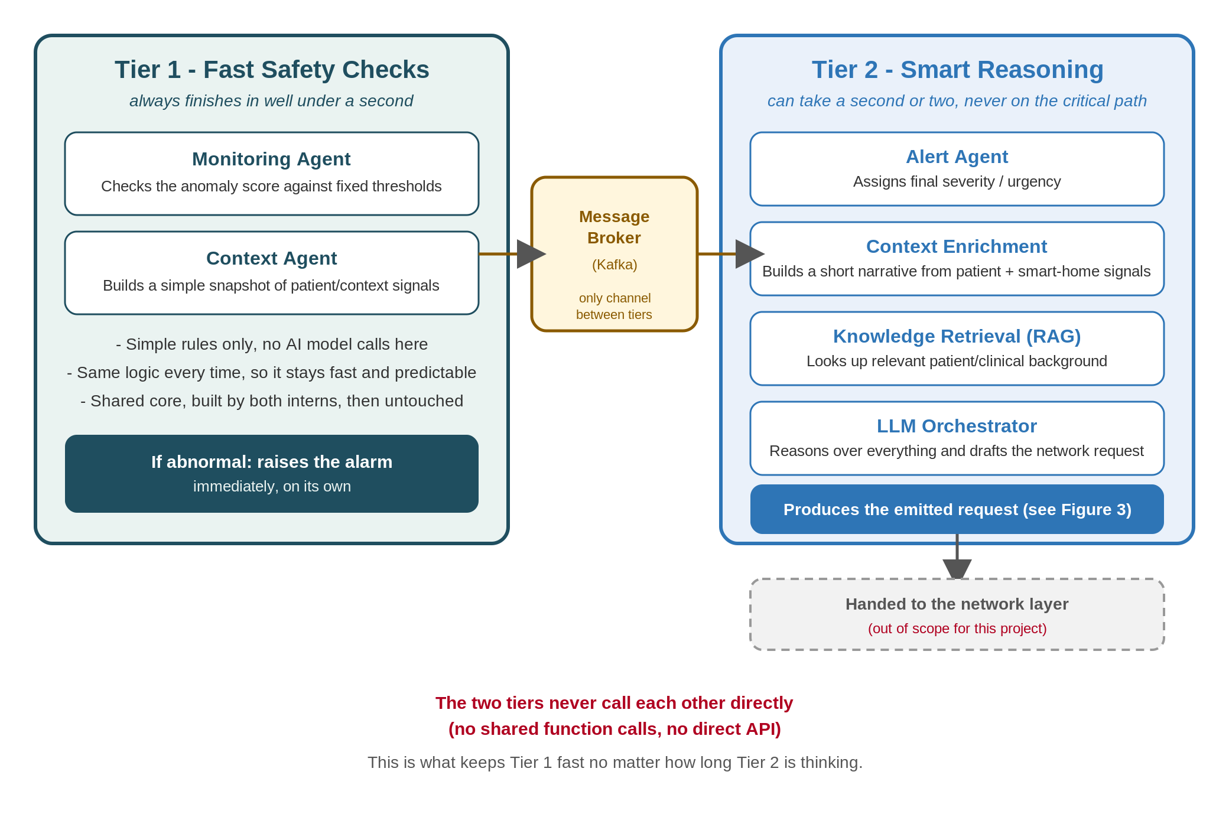
Figure 2 — Tier 1 (fast, rule-based) and Tier 2 (slower, reasoning-based). Track A owns everything inside Tier 2.
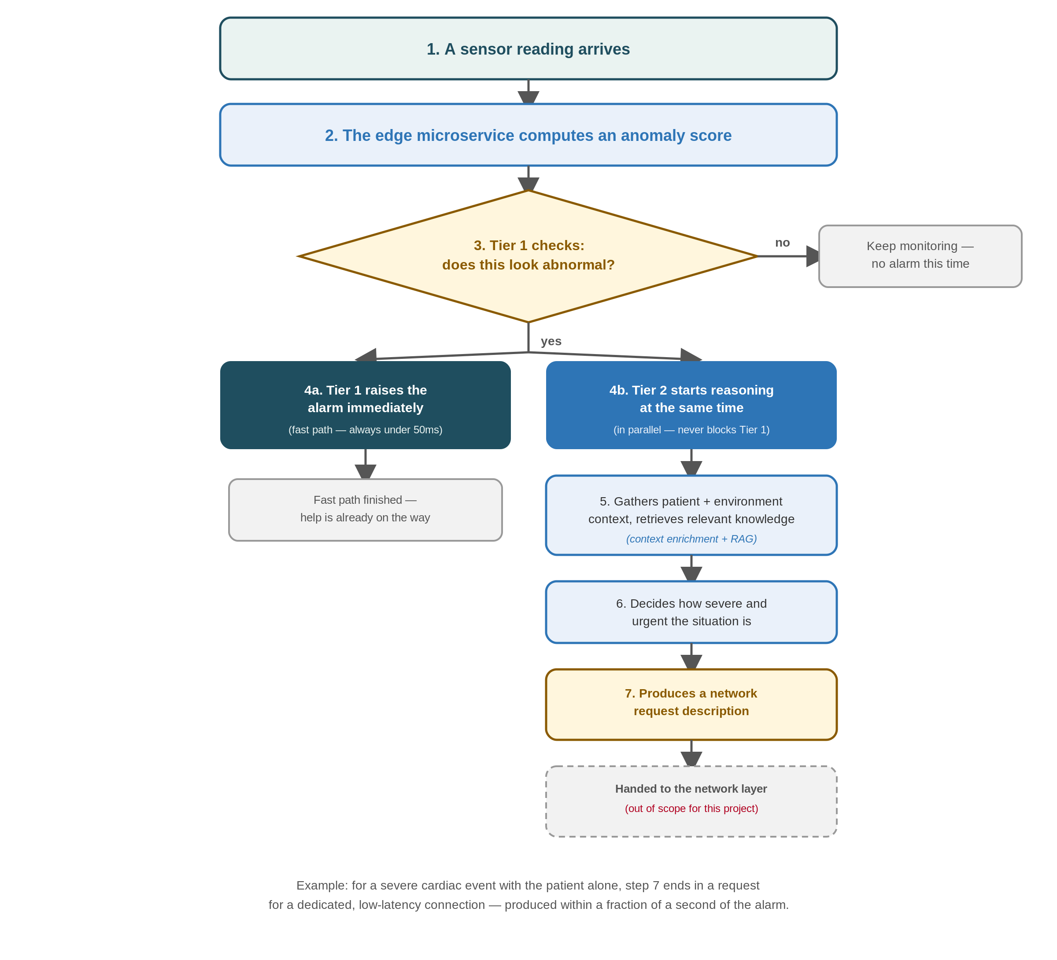
Figure 3 — The end-to-end workflow. Track A owns steps 4b through 7.

